Partial / residual correlation: GBPUSD and USDCAD
Method 07 / daily log returns / leave-currency-out USD factor / Alpari D1 full available history

Study setup
Logical pair: GBPUSD , USDCAD
Broker symbols: GBPUSD_i , USDCAD_i
Snapshot: 2026-11-03_majors_alpari_D1
Timeframe: D1
Matched return window: 1999-01-05 to 2026-11-02 (UTC bar dates)
Matched return count n: 7148
Dropped unfinished last bar dated 2026-11-03 UTC after a tick-volume check against the prior complete day.
USD-strength sign rule: minus log return when USD is the quote (EURUSD, GBPUSD, AUDUSD, NZDUSD); plus log return when USD is the base (USDJPY, USDCHF, USDCAD). EURGBP is never a constituent.
Control z constituents (5): EURUSD, AUDUSD, NZDUSD, USDJPY, USDCHF
z_t = equal-weight mean of those USD-strength returns on the same day
Complete matched rows (Excel): GBPUSD-USDCAD_Partial_D1.xlsx
Complete matched rows (HTML table): GBPUSD-USDCAD_Partial_D1_data.html

Method carried forward
Partial / residual correlation regresses each matched daily log return of close, ln(close_t / close_t-1), on the same leave-currency-out USD strength factor z, then takes Pearson correlation of the two residual series. Quotes are not inverted. z is the equal-weight mean of USD-strength returns from other majors that do not share a non-USD currency with either leg; EURGBP is never a constituent. USD-strength is minus the log return when USD is the quote (EURUSD, GBPUSD, AUDUSD, NZDUSD) and plus the log return when USD is the base (USDJPY, USDCHF, USDCAD). OLS uses an intercept on each leg. rho_partial is symmetric under swap of the two symbols. It describes leftover linear co-movement after removing linear z; it is not a cause, not a lead, and not a trading signal. Daily rows are not independent and residuals are estimated, so the two-sided p-value and Fisher interval are secondary. Same-sample raw Pearson r is a side check only.

Regression on z
leg | intercept_a_or_c | slope_b_or_d | R2
GBPUSD | -2.94e-05 | -0.7251551 | 0.41843762
USDCAD | -4.73e-06 | 0.57626623 | 0.31830831

Results
rho_partial: -0.145742
Two-sided p-value: 3.11555e-35
Approximate 95% Fisher interval: [-0.168356, -0.122974]
Same-sample raw Pearson r: -0.456720
rho_partial minus r: 0.310978

Conclusion
Over 7148 matched daily rows for GBPUSD and USDCAD after removing a leave-currency-out USD factor built from 5 constituents, rho_partial is -0.1457 (negative, weak residual linear link in this sample). Approximate 95% Fisher interval: [-0.1684, -0.1230]. Same-sample raw Pearson r is -0.4567 (partial minus r = 0.3110). Leg R-squared on z: GBPUSD=0.4184, USDCAD=0.3183. Two-sided p under the usual independent-pairs model is 3.116e-35; residuals are estimated and daily FX rows are linked, so treat p as secondary. This does not establish cause, lead-lag, or a lasting trading rule.

Charts
Daily closes
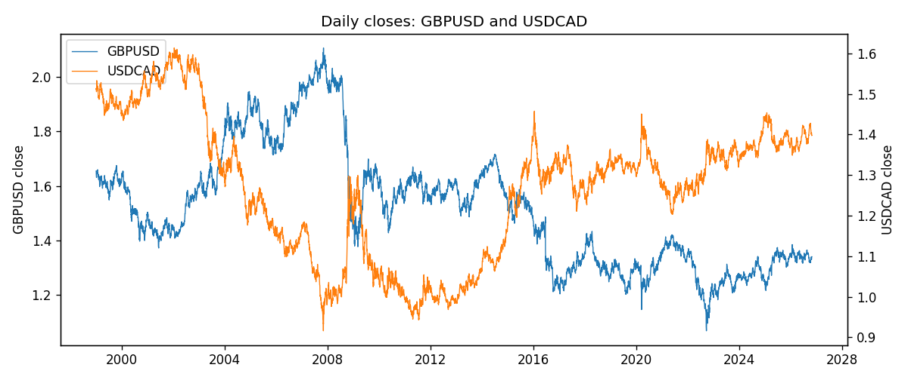
Log returns and control z
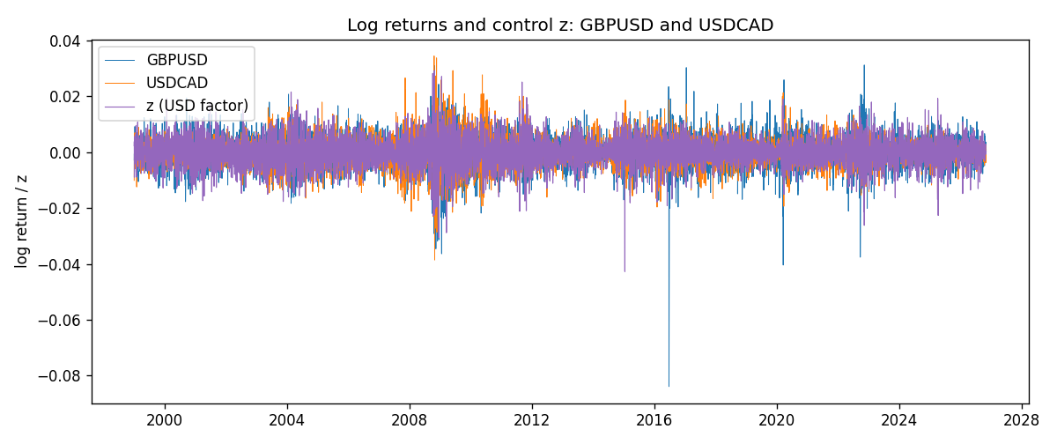
Residual scatter e_x vs e_y
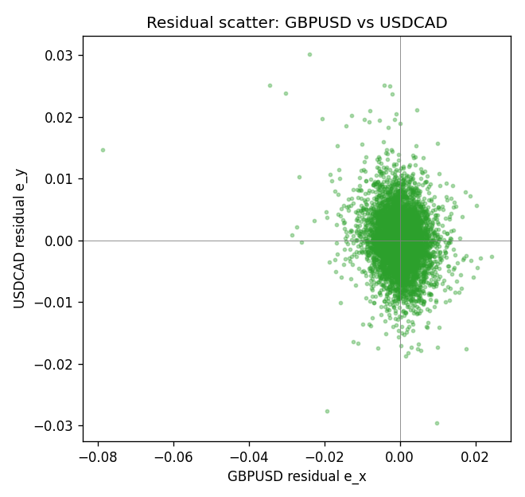

Data report
Every matched row that entered the partial correlation is stored in the sibling Excel workbook named GBPUSD-USDCAD_Partial_D1.xlsx. That file is the complete data archive for redrawing charts. Embedding all rows as a Word table is impractical at this length; the Word file holds the column list, column summaries, and the first and last 15 matched rows.
Columns: time, GBPUSD_open, USDCAD_open, GBPUSD_high, USDCAD_high, GBPUSD_low, USDCAD_low, GBPUSD_close, USDCAD_close, GBPUSD_tick_volume, USDCAD_tick_volume, GBPUSD_spread, USDCAD_spread, GBPUSD_real_volume, USDCAD_real_volume, GBPUSD_log_return, USDCAD_log_return, usd_strength_EURUSD, usd_strength_AUDUSD, usd_strength_NZDUSD, usd_strength_USDJPY, usd_strength_USDCHF, z, GBPUSD_fitted, USDCAD_fitted, GBPUSD_resid, USDCAD_resid
Column summaries (matched calculation rows)
column | count | mean | std | min | 25% | 50% | 75% | max
GBPUSD_open | 7148 | 1.5147424 | 0.21801364 | 1.06854 | 1.3240425 | 1.50985 | 1.629975 | 2.1066
USDCAD_open | 7148 | 1.2664001 | 0.16881677 | 0.9168 | 1.1174225 | 1.29842 | 1.3719025 | 1.6183
GBPUSD_high | 7148 | 1.5210395 | 0.21858109 | 1.08366 | 1.32902 | 1.516685 | 1.6374625 | 2.1161
USDCAD_high | 7148 | 1.2712993 | 0.16876756 | 0.9336 | 1.1224 | 1.30385 | 1.3760825 | 1.619
GBPUSD_low | 7148 | 1.5084277 | 0.21724232 | 1.03518 | 1.3186875 | 1.50192 | 1.6233 | 2.0983
USDCAD_low | 7148 | 1.2618444 | 0.16884966 | 0.9056 | 1.1128375 | 1.29351 | 1.367575 | 1.6102
GBPUSD_close | 7148 | 1.5148153 | 0.21797449 | 1.06879 | 1.324035 | 1.50993 | 1.6299575 | 2.1065
USDCAD_close | 7148 | 1.2664179 | 0.16878481 | 0.916 | 1.117435 | 1.298405 | 1.3722025 | 1.6137
GBPUSD_tick_volume | 7148 | 95468.138 | 153933.58 | 62 | 10088.75 | 53396.5 | 92022.25 | 1273370
USDCAD_tick_volume | 7148 | 81445.79 | 147602.47 | 56 | 5642.25 | 41126 | 71764.5 | 1410818
GBPUSD_spread | 7148 | 26.846531 | 19.190643 | 0 | 10.75 | 20 | 50 | 50
USDCAD_spread | 7148 | 23.322888 | 18.222444 | 0 | 9 | 17 | 40 | 60
GBPUSD_real_volume | 7148 | 3.582457e+09 | 8.4750162e+10 | 0 | 0 | 0 | 0 | 2.4038164e+12
USDCAD_real_volume | 7148 | 1.8476363e+10 | 9.6948735e+10 | 0 | 0 | 0 | 0 | 2.5751613e+12
GBPUSD_log_return | 7148 | -1.992e-05 | 0.00564699 | -0.08388241 | -0.0031217 | 3.426e-05 | 0.00318167 | 0.03112653
USDCAD_log_return | 7148 | -1.226e-05 | 0.00514518 | -0.03859748 | -0.00283513 | 4.873e-05 | 0.00272781 | 0.03436319
usd_strength_EURUSD | 7148 | 2.16e-06 | 0.0058013 | -0.03433183 | -0.00325609 | -0 | 0.00324218 | 0.03123819
usd_strength_AUDUSD | 7148 | -3.157e-05 | 0.00755018 | -0.0806166 | -0.00415111 | -0.00029168 | 0.00385014 | 0.08602525
usd_strength_NZDUSD | 7148 | -1.914e-05 | 0.00764519 | -0.05966839 | -0.004586 | -0.00023666 | 0.00424201 | 0.07027433
usd_strength_USDJPY | 7148 | 5.267e-05 | 0.00620906 | -0.03908203 | -0.00319392 | 0.00012736 | 0.00340928 | 0.05184024
usd_strength_USDCHF | 7148 | -6.945e-05 | 0.0065937 | -0.19545699 | -0.00334697 | 8.15e-05 | 0.00331954 | 0.09051364
z | 7148 | -1.307e-05 | 0.00503735 | -0.04274064 | -0.0028936 | 4.524e-05 | 0.00291486 | 0.02916153
GBPUSD_fitted | 7148 | -1.992e-05 | 0.00365286 | -0.02117603 | -0.00214312 | -6.22e-05 | 0.00206891 | 0.03096419
USDCAD_fitted | 7148 | -1.226e-05 | 0.00290285 | -0.02463472 | -0.00167221 | 2.134e-05 | 0.00167501 | 0.01680007
GBPUSD_resid | 7148 | 0 | 0.00430641 | -0.07873776 | -0.00216643 | 7.749e-05 | 0.0023053 | 0.02419571
USDCAD_resid | 7148 | -0 | 0.0042481 | -0.02953795 | -0.0023586 | -8.4e-07 | 0.00235029 | 0.03015535
First 15 matched rows (selected columns)
time | GBPUSD_close | USDCAD_close | GBPUSD_log_return | USDCAD_log_return | z | GBPUSD_fitted | USDCAD_fitted | GBPUSD_resid | USDCAD_resid
1999-01-05 | 1.6547 | 1.5123 | -0.0028966287 | -0.010131666 | 0.0022527594 | -0.0016629954 | 0.0012934584 | -0.0012336333 | -0.011425124
1999-01-06 | 1.6537 | 1.5118 | -0.00060452184 | -0.0003306769 | 0.0037675445 | -0.0027614495 | 0.0021663779 | 0.0021569277 | -0.0024970548
1999-01-07 | 1.6502 | 1.5141 | -0.002118709 | 0.0015202092 | -0.0090058746 | 0.0065012605 | -0.0051945122 | -0.0086199695 | 0.0067147214
1999-01-08 | 1.6405 | 1.511 | -0.0058954193 | -0.0020495197 | 0.0034819768 | -0.0025543686 | 0.0020018149 | -0.0033410506 | -0.0040513346
1999-01-11 | 1.6312 | 1.5057 | -0.0056851331 | -0.0035137769 | -0.0042615246 | 0.0030608709 | -0.0024605035 | -0.0087460041 | -0.0010532734
1999-01-12 | 1.6349 | 1.5157 | 0.0022657001 | 0.0066194721 | 0.0056298057 | -0.0041118777 | 0.0032395361 | 0.0063775778 | 0.003379936
1999-01-13 | 1.6499 | 1.5226 | 0.0091330396 | 0.0045420214 | -0.00062065926 | 0.00042067885 | -0.00036239577 | 0.0087123608 | 0.0049044172
1999-01-14 | 1.6531 | 1.5332 | 0.0019376331 | 0.0069376546 | 9.1379238e-05 | -9.5659499e-05 | 4.7927976e-05 | 0.0020332926 | 0.0068897267
1999-01-15 | 1.6502 | 1.5245 | -0.0017558204 | -0.0056905671 | 0.0054499412 | -0.003981448 | 0.0031358863 | 0.0022256277 | -0.0088264534
1999-01-18 | 1.6522 | 1.526 | 0.0012112405 | 0.00098344542 | -0.0011619768 | 0.000813218 | -0.00067433877 | 0.00039802246 | 0.0016577842
1999-01-19 | 1.6553 | 1.5302 | 0.0018745281 | 0.002748513 | -0.0029208788 | 0.0020886948 | -0.0016879346 | -0.00021416662 | 0.0044364476
1999-01-20 | 1.6472 | 1.5211 | -0.0049053846 | -0.0059646885 | -5.964573e-05 | 1.3857027e-05 | -3.9102614e-05 | -0.0049192416 | -0.0059255859
1999-01-21 | 1.6524 | 1.5146 | 0.0031518998 | -0.0042823796 | -0.00064442878 | 0.00043791544 | -0.00037609334 | 0.0027139844 | -0.0039062863
1999-01-22 | 1.6565 | 1.5184 | 0.0024781662 | 0.0025057712 | 0.0062817303 | -0.0045846241 | 0.0036152183 | 0.0070627903 | -0.0011094471
1999-01-25 | 1.6585 | 1.5197 | 0.0012066366 | 0.00085579808 | 0.0011260072 | -0.00084592525 | 0.00064414914 | 0.0020525619 | 0.00021164894
Last 15 matched rows (selected columns)
time | GBPUSD_close | USDCAD_close | GBPUSD_log_return | USDCAD_log_return | z | GBPUSD_fitted | USDCAD_fitted | GBPUSD_resid | USDCAD_resid
2026-10-13 | 1.32534 | 1.4214 | 0.0036434319 | -0.0046395653 | -0.0032725056 | 0.0023436787 | -0.0018905653 | 0.0012997531 | -0.002749
2026-10-14 | 1.31884 | 1.42356 | -0.0049164679 | 0.0015184751 | 0.0024045656 | -0.0017730784 | 0.0013809392 | -0.0031433896 | 0.00013753591
2026-10-15 | 1.32757 | 1.41843 | 0.0065976411 | -0.0036101503 | -0.0028924108 | 0.0020680511 | -0.0016715295 | 0.00452959 | -0.0019386209
2026-10-16 | 1.33257 | 1.41357 | 0.0037592051 | -0.0034322068 | -0.0029832148 | 0.0021338981 | -0.0017238568 | 0.001625307 | -0.00170835
2026-10-19 | 1.33024 | 1.41091 | -0.0017500314 | -0.0018835331 | 0.00053832269 | -0.00041976282 | 0.00030548639 | -0.0013302686 | -0.0021890195
2026-10-20 | 1.3377 | 1.40569 | 0.0055923442 | -0.0037066008 | -0.0028905861 | 0.0020667279 | -0.001670478 | 0.0035256164 | -0.0020361229
2026-10-21 | 1.33937 | 1.4045 | 0.0012476328 | -0.00084691787 | -0.0014215227 | 0.0010014291 | -0.00082390633 | 0.00024620377 | -2.3011543e-05
2026-10-22 | 1.33967 | 1.40081 | 0.00022396082 | -0.0026307268 | -0.0014464332 | 0.001019493 | -0.00083826139 | -0.00079553219 | -0.0017924654
2026-10-23 | 1.33684 | 1.40085 | -0.0021146949 | 2.85545e-05 | 0.00037445772 | -0.00030093531 | 0.00021105655 | -0.0018137596 | -0.00018250205
2026-10-26 | 1.33359 | 1.40093 | -0.0024340661 | 5.7106554e-05 | 0.0028676005 | -0.0021088505 | 0.0016477706 | -0.00032521562 | -0.001590664
2026-10-27 | 1.33044 | 1.40449 | -0.0023648393 | 0.0025379458 | 0.0016249143 | -0.0012077102 | 0.00093165242 | -0.0011571291 | 0.0016062933
2026-10-28 | 1.33254 | 1.39911 | 0.0015771808 | -0.0038379274 | 0.00028790762 | -0.00023817306 | 0.00016118065 | 0.0018153538 | -0.003999108
2026-10-29 | 1.33733 | 1.39895 | 0.0035881935 | -0.00011436495 | -0.00080718849 | 0.00055594147 | -0.00046988626 | 0.0030322521 | 0.00035552131
2026-10-30 | 1.33913 | 1.39751 | 0.0013450605 | -0.0010298736 | -8.069444e-05 | 2.9120606e-05 | -5.1232275e-05 | 0.0013159399 | -0.0009786413
2026-11-02 | 1.3406 | 1.39837 | 0.0010971256 | 0.00061519094 | 0.00017842052 | -0.00015877793 | 9.8086928e-05 | 0.0012559035 | 0.00051710402

